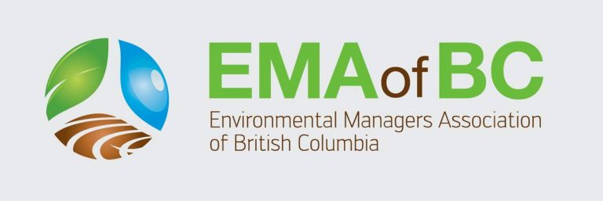
EMA of BC Indigenous Project Award
2024 Nomination Form

Lead Indigenous Organization:

Name of Project Owner:

Project, Program, or Study Title:

Anticipated Project Start Date:

Anticipated Project End Date:

Eligibility Checklist:
- Is the lead organization or business 50% or more indigenous-owned (including business partnerships)?
YES NO

- Is the project, program, or study based in British Columbia?
YES NO

- Will the project, program, or study happen in 2024?
YES NO

- What is the focus of the project, program, or study? (Check one):
- Ecosystem restoration
- Environmental studies or research
- Traditional ecological knowledge

- Please provide your approximate budget and explain how EMA of BC’s $2,000 in funds will be used, if awarded (please use space on second page, or attach separate sheet).

EMA of BC Indigenous Project Award Eligibility Criteria:
• The project, program, or study needs to be based in BC.
• The organization or business needs to be 50% or more indigenous-owned (including business partnerships).
• Initiatives need to be focused on either 1) Ecosystem restoration; 2) Environmental studies or research; or 3) Traditional ecological knowledge.
• Projects and programs must be initiated or ongoing in 2024.
• Projects need to demonstrate their approximate budget and explain how EMA of BC’s $2,000 in funds will be used.

Each organization can submit up to two projects. Deadline for application is May 31, 2024. EMA of BC staff and directors will select a winning project and contact the winners. The project will be announced publicly at the EMA of BC gala on June 13, 2024.

Submit Nomination Form via email to info@emaofbc.com .

